Deliverables – I

FINAL YEAR PROJECT

BY;

MUHAMMAD HASSAN

1612195

MUHAMMAD DANIYAL

1612238

**ERD**

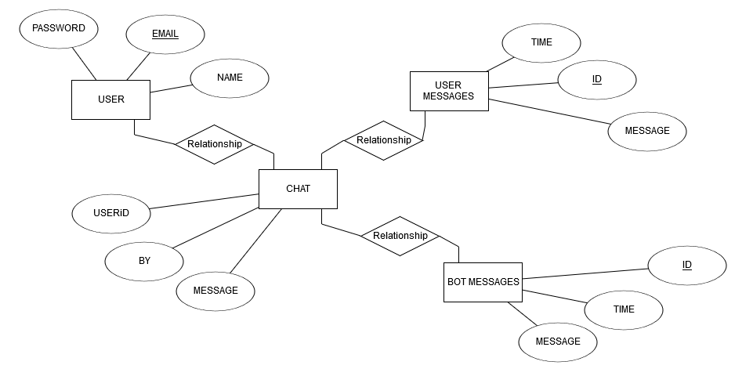

**ITERATION PLAN – I**



**DOMAIN MODEL**



**USE CASE**



**ACTIVITY DIAGRAMS**

**(i)**



**(ii)**



**(iii)**



**USE CASES**

**(i)**

|  |  |
| --- | --- |
| **ID:** | **-** |
| **Title:** | LOGIN |
| **Description:** | THROUGH THIS FEATURE USER WILL BE ABLE TO ACCESS HIS/HER PROFILE |
| **Primary Actor:** | THE USER HIMSELF/HERSELF |
| **Preconditions:** | THERE WILL BE A SIMPLE WEB PAGE THAT WILL ASK THE USER TO SIGN IN TO ACCESS THE PROFILE |
| **Postconditions:** | AFTER LOGGING IN, USER WILL BE ABLE TO ACCESS THE PROFLE AND CONTINUE CHATTING WITH THE BOT |
| **Main  Success Scenario:** | AT THE BIGENNIHG, USER WILL BE SHOWN A WEB PAGE IN WHERE S(HE) WILL BE ASKED TO ENTER EMAIL AND PASSWORD. ON ENTERING THE ASKED DETAILS, S(HE) WILL BE REDIRECTED TO THE CHATROOM |
| **Extensions:** | THERE IS A POSSIBILITY THAT USER WILL ENTER WRONG PASSORD OR MAY NOT HAVE ACCOUNT AND JUST FILLING THE FIELD. THIS WILL GIVE EXCPETION THAT LIKE ‘USER NOT FOUND’ OR ‘WRONG EMAIL OR PASSWORD’ |
| **Frequency of Use:** | EVERY TIME WHEN USER VISITS WEB PAGE |
| **Status:** | DESIGN IS COMPLETED AND IMPLEMENTATION IS LEFT |
| **Owner:** | BOTH THE TEAM MEMBERS |
| **Priority:** | HIGH. CAUSE IT WILL ACCESS THE PROFILE |

**(ii)**

|  |  |
| --- | --- |
| **ID:** | **-** |
| **Title:** | REGISTER |
| **Description:** | USER WILL CREATE HIS PROFILE TO GET ACCESS TO THE CHATROOM |
| **Primary Actor:** | USER HIMSELF/HERSELF |
| **Preconditions:** | THERE WILL BE A SIGNUP OPTION AVAILABLE FOR NEW USER |
| **Postconditions:** | HE WILL BE ABLE TO ACCESS THE CHATROOM ON HIS OWN PROFIILE |
| **Main  Success Scenario:** | TO MAKE USER A PERTICIPENT OF THE PROTAL SO THAT HE WILL BE ABLE TO AVAIL THE BOT COUNSELLING |
| **Extensions:** | WHEN USER GIVE WRONG DETAILE OR NOT ACCORDING TO THE GIVEN INSTRUCTIONS |
| **Frequency of Use:** | FIRST TIME ONLY WHEN USER IS NEW |
| **Status:** | DESIGN IS COMPLETED AND IMPLIMENTATION IS LEFT |
| **Owner:** | BOTH OF TEAM MEMBERS |
| **Priority:** | HIGH, AS CREATING PROFILE IS IMPORTANT |

**(iii)**

|  |  |
| --- | --- |
| **ID:** | **-** |
| **Title:** | CHAT |
| **Description:** | THIS IS A MAIN FEATURE ON WHICH WHOLE PRODUCT IS DEPEND UPON. WHERE USER WILL CHAT WITH THE BOT TO GET COUNSELLING |
| **Primary Actor:** | THE USER AND THE BOT. BOTH ARE PRIMARY, AS IT’S A CONVERSATION BETWEEN BOTH SIDES |
| **Preconditions:** | BOT WILL BE EXPECTING A SENSIBLE TEXT FROM THE USER THAT CAN BE INTERPRETED EASILY BY BOT |
| **Postconditions:** | THAT TEXT WILL BE INTERPRETED BY THE BOT AND USER WILL SEE THE RESPONSE ACCORDING TO THE TEXT THAT USER HAS ENTERED |
| **Main  Success Scenario:** | USER WILL ENTER A TEXT THAT WILL BE RELEVENT TO THE DATASET WITH WHICH BOT HAS BEEN TRAINED. THE BOT WILL INTERPRET THE TEXT AND WILL REPSOND ACCORDINGLY |
| **Extensions:** | WHEN USE WILL ENTER AN UNSENSIBLE TEXT OR THE TEXT WHICH IS IRRELIVENT, THE BOT WILL RESPOND THE TEXT LIKE ‘I CAN’T UNDERSTAND, TRY OTHER WAY’ OR ANY OTHER EXCUSE |
| **Frequency of Use:** | AS IT IS THE MAIN FEATURE OF PRODUCT, SO THIS WILL BE USED VERY OFTEN. LIKE EVERY CLICK WILL BE FOR THE CHAT |
| **Status:** | DESIGN IS DONE AND IMPLIMENTATION WILL BE DONE BY THE END OF THE PRODUCT DEADLINE |
| **Owner:** | BOTH THE TEAM MEMBERS |
| **Priority:** | HEIGHEST. CAUSE PRODUCT IS USELESS WITHOUT THIS FEATURE |

**GANTT CHAT**

